1. Create user with name Techie and provide sudo access to user.

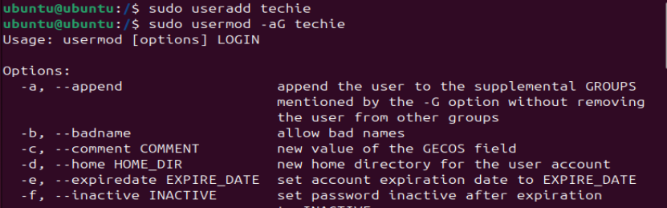

1. Navigate to the home directory.

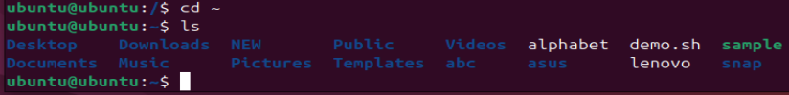

1. Create a new directory.

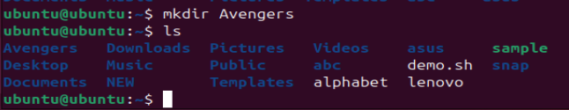

1. List the contents of a directory.

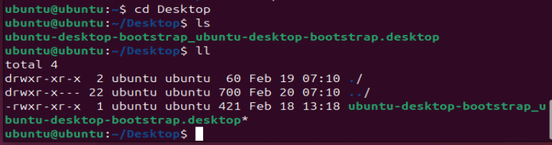

1. Change the current directory.

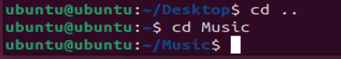

1. Create a new empty file. 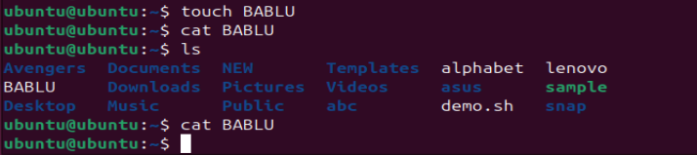
2. View the contents of a file.



1. Copy a file to another location.

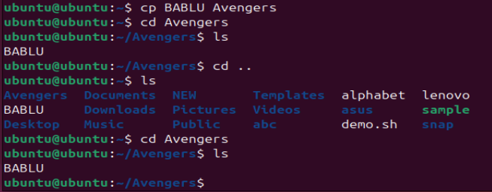

1. Move a file to another location.

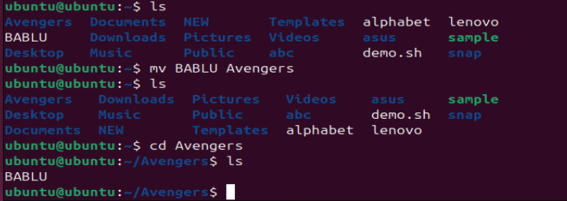

1. Rename a file.

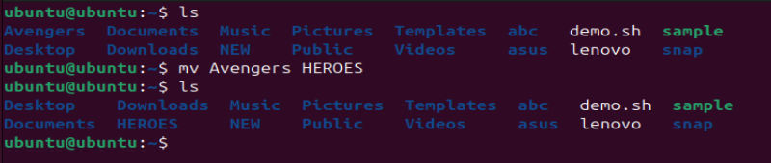

1. Delete a file.

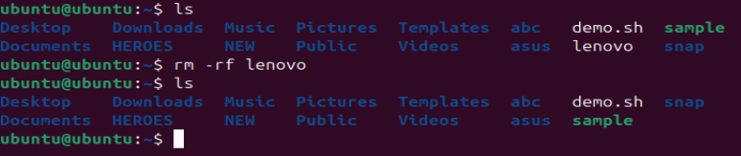

1. Grant or revoke permissions on a file or directory.

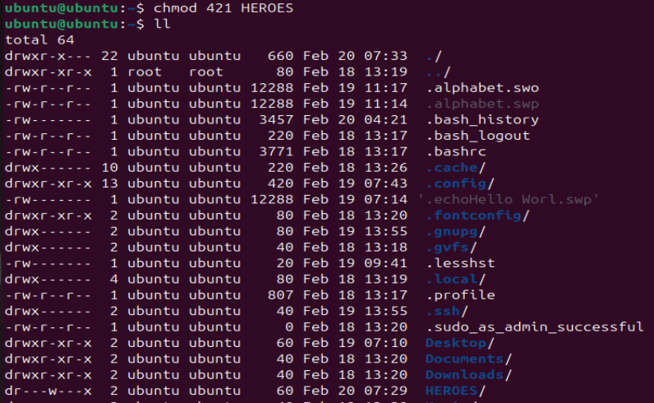

1. View the current date and time.

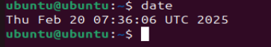

1. Check the system uptime.

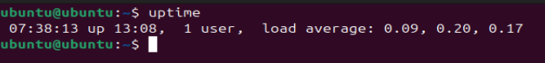

1. View the running processes.

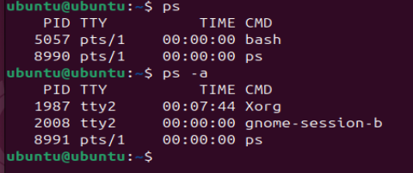

1. Kill a running process.

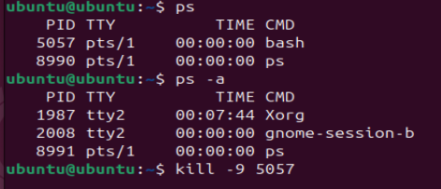

1. Install a package using the package manager (e.g., apt or yum).

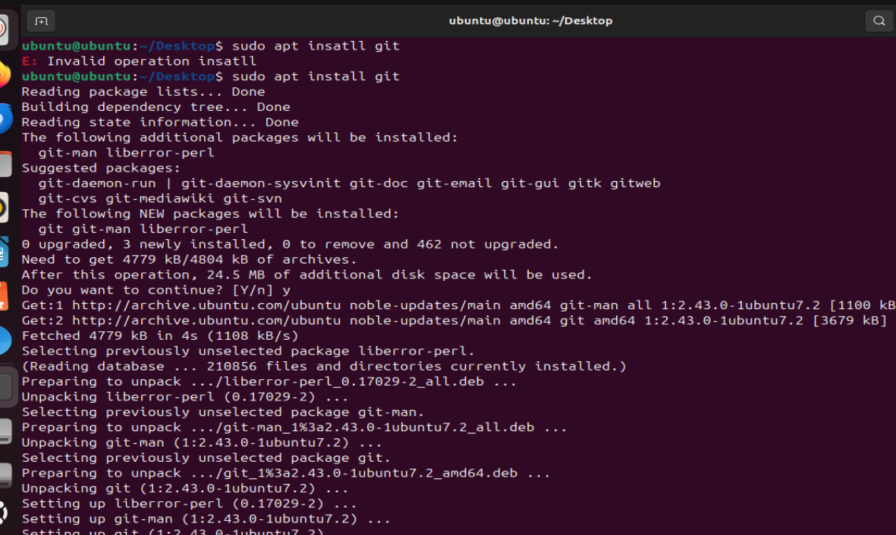

1. Update the system packages.

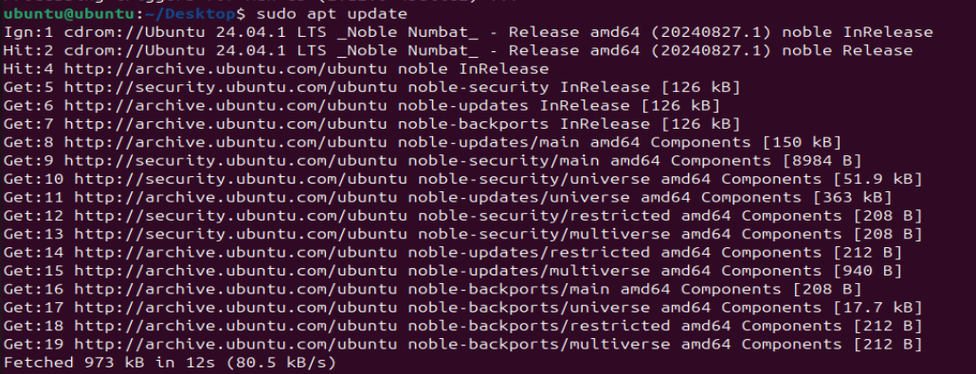

1. Create a symbolic link.

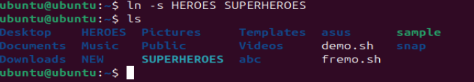

1. Search for files using the find command.

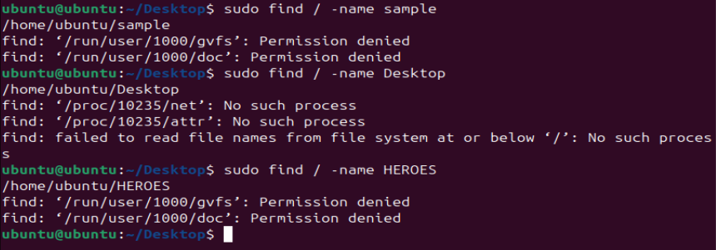

1. Compress and decompress files using tar

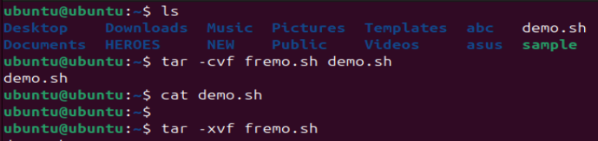

1. Monitor system resources with top or htop

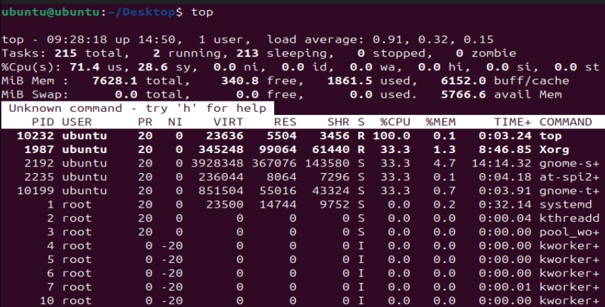

1. Create and manage user groups.

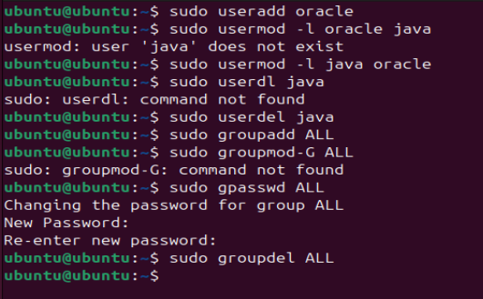

25) Monitor log files using tail or grep.



26) Set up a web server (e.g., Apache or Nginx).

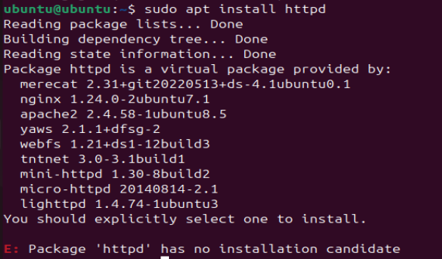

27) Configure and secure a MySQL Database.

28) Set up a Application Server (e.g.,Apache Tomcat)

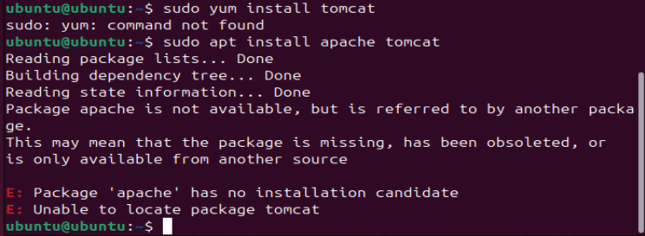

29) create a service file for Apache Tomcat.(Should execute by using systemtctl command)